**🦋 Enchanted Wings:  
Marvels of Butterfly Species**

**TEAM MATES:**

Hinge Karan Teja (Team Lead)

D S V Sri Mounica (Team member)

Veeranki Moni Sushmitha (Team member)

Syed Irfan (Team member)

**INTRODUCTION**

Butterflies are not only beautiful and fascinating creatures, but they also serve as vital indicators of a healthy environment and ecosystem. Identifying butterfly species manually can be challenging, time-consuming, and requires expert knowledge.

Enchanted Wings is an AI-powered web application designed to simplify this process using the power of deep learning. By leveraging the VGG16 pre-trained model, the application classifies butterfly images into their respective species with high accuracy. This project aims to combine artificial intelligence with ecological awareness, allowing users—from students to researchers—to identify butterfly species easily through a clean and interactive web interface. Whether it's for educational, scientific, or personal curiosity, *Enchanted Wings* opens the door to exploring butterfly diversity with just a single image**.**

**OBJECTIVE**

• Purpose:  
To automate the classification of butterfly species using a deep learning model (VGG16) and present predictions through a user-friendly web interface.  
  
• Features:  
 ✅ Upload butterfly images  
 ✅ Real-time species prediction  
 ✅ Clean and responsive UI  
 ✅ About & Contact pages for information

**TECHNOLOGIES USED**  
- Python, TensorFlow / Keras, VGG16, Flask, HTML/CSS, Bootstrap, OpenCV, Pandas  
📊 Dataset:  
- Custom butterfly dataset  
- Training_set.csv and Testing_set.csv  
- Images resized to 224x224 for VGG16

**Architecture**

• Frontend:  
 - HTML5, CSS3, Bootstrap 5  
 - Carousel, navigation, upload form  
• Backend:  
 - Python Flask handles routing, image processing, and model inference  
 - TensorFlow/Keras used for deep learning  
• Model:  
 - VGG16 (pre-trained), customized with new dense layers for butterfly classes  
 - Trained with butterfly image dataset  
• Database:  
 - Not used — the project is stateless and uses image-based inference only

**Setup Instructions**

• Prerequisites:  
 - Python 3.10+  
 - pip  
 - TensorFlow, Flask, OpenCV, Pandas, NumPy  
• Installation:  
 git clone https://github.com/yourusername/butterfly-classification.git  
 cd butterfly-classification  
 pip install -r requirements.txt

**Folder Structure**

project-root/  
├── static/ # Images, CSS  
├── templates/ # HTML templates  
├── app.py # Main Flask app  
├── script.py # Model training script  
├── vgg16_model.h5 # Saved model  
├── Training_set.csv  
├── Testing_set.csv  
└── requirements.txt

**Running the Application**

• Command:  
 python app.py  
  
• Then open browser to: http://127.0.0.1:5000

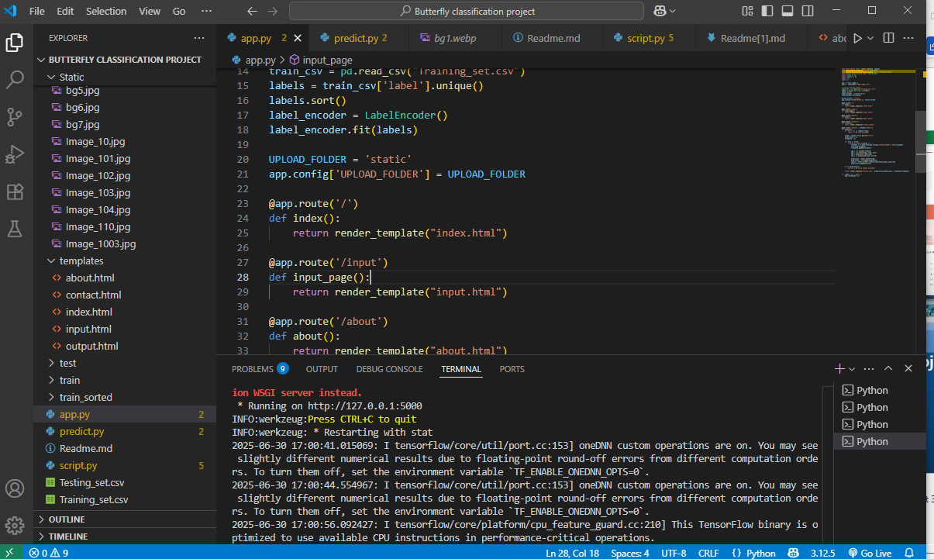

**API Documentation**

• Endpoints:  
 - / → Home  
 - /input → Upload page  
 - /predict → Prediction endpoint (POST)  
 - /about, /contact → Info pages

# Methodology

1. Load and preprocess images from CSV  
2. Encode labels using LabelEncoder & one-hot encoding  
3. Transfer Learning with VGG16:  
 - Remove top layer, add custom dense layers  
4. Train and evaluate model  
5. Save model and connect it to Flask app.

**FUNCTIONAL AND PERFORMANCE TESTING**

**Performance Testing** Tested with multiple butterfly images to check accuracy and quick response of the web application on localhost

**RESULTS**

1. **Homepage**:

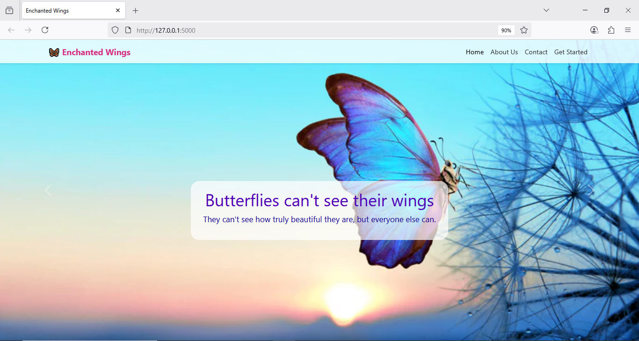

**2. About Us page:**

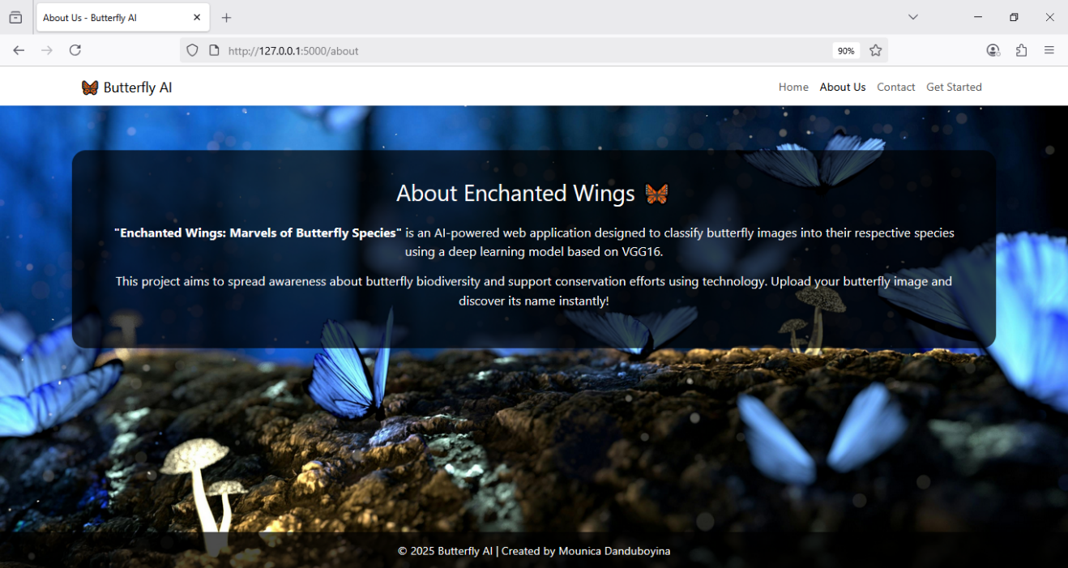

**3.Contact Page:**

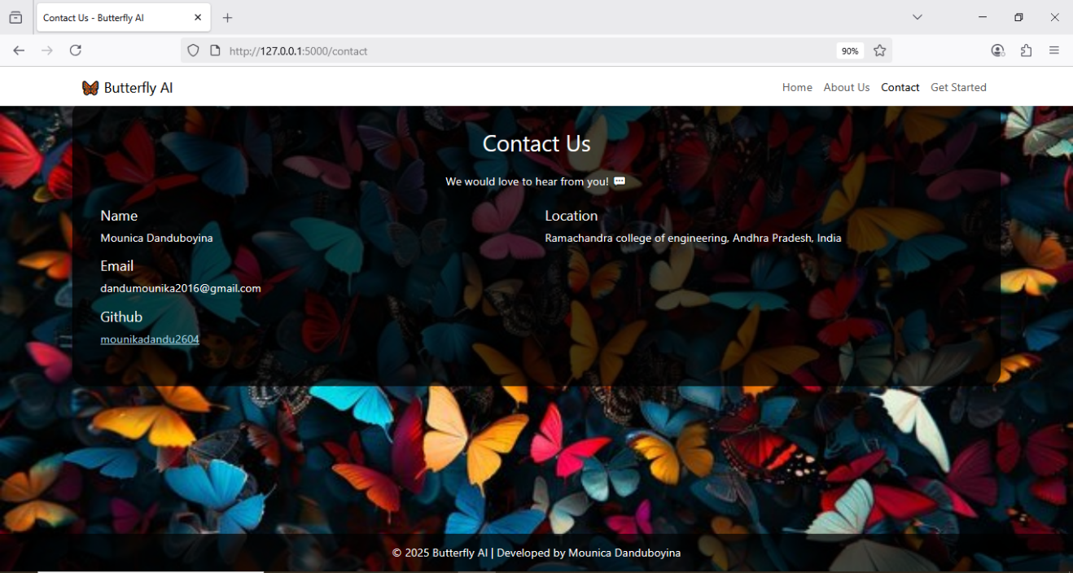

**4. Upload Page:**

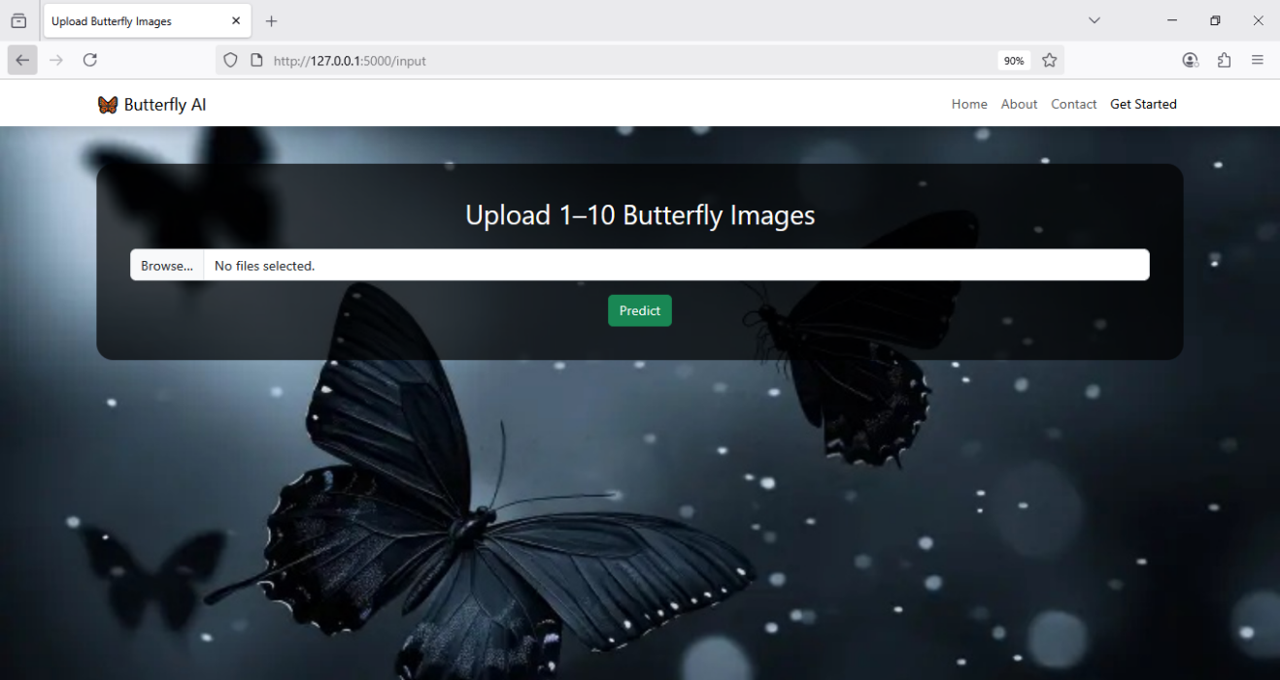

**6. Output Prediction Page:**

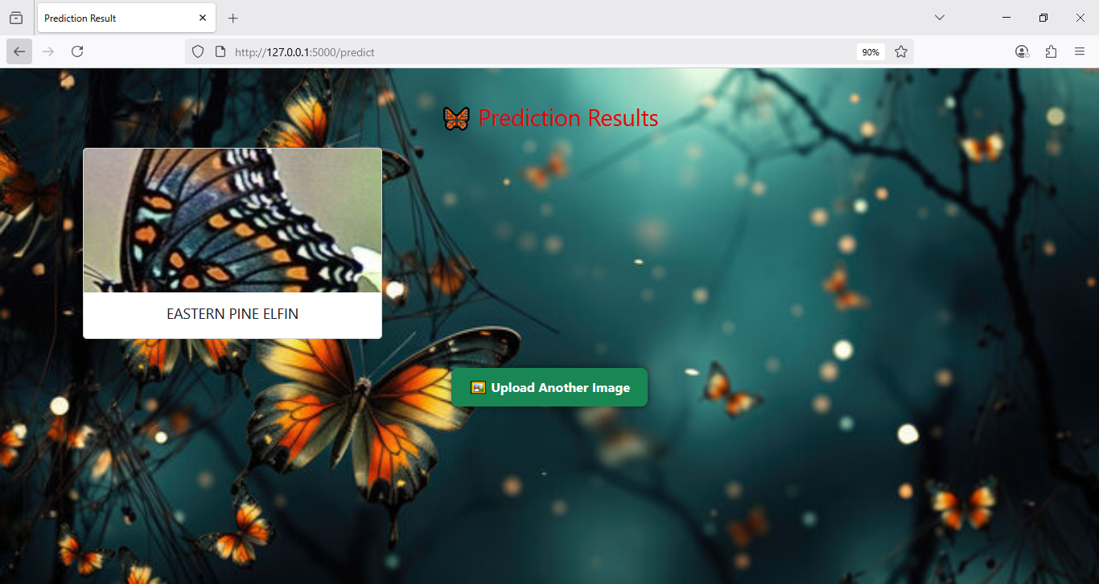

**Advantages**

* Eco-Friendly & Educational:  
  Promotes awareness about butterfly species and biodiversity through AI.
* Fast & Accurate:  
  Classifies butterfly images in real-time using a trained VGG16 deep learning model.
* Easy to Use:  
  Simple and clean web interface — no technical expertise required.
* Uses Transfer Learning:  
  Utilizes a pre-trained VGG16 model, reducing the need for training from scratch and improving efficiency.

**Disadvantages / Limitations**

* Requires High-Quality Images:  
  Blurry or low-resolution images may lead to inaccurate predictions.
* Limited Species Dataset:  
  The model can only predict species it was trained on — unfamiliar species won't be classified correctly.
* No Authentication or User History:  
  All users access the same interface; there's no login

**FUTURE SCOPE**

• Include more species and larger dataset.

• Build a mobile app version.

• Add detailed butterfly information with each prediction.

**CONCLUSION**

This project successfully built a butterfly classification web app using Deep Learning (VGG16) and Flask. It helps in identifying species for educational and research purposes efficiently.

**🌸 Thank you 🦋**